Yubico配置使用手册
目录
1 前言 2
2 环境需求 2
3 软件安装 2
3.1 客户端的软件 2
3.2 服务器端软件 3
4 Yubico的配置步骤 3
4.1 Yubikey的初始化(初次使用,初始化可以略过), 3
4.2 生成外部主密钥 4
4.3 生成签名子密钥 6
4.4 备份密钥 8
4.5 把签名子密钥导入key 8
4.6 导出签名密钥的公钥 11
5 服务器端的软件安装及配置 11
5.1 上传公钥到linux 服务器，进行公钥配置 11
5.2 ssh_config的配置 12
6 登录测试 12
6.1 插入yubikey,打开pageant.exe 12
6.2 打开putty 13
7 其他 15
7.1 修改yubikeyPIN码 15

前言
配置多个yubikey,登录同一个linux 服务器，实现yubico登录

环境需求
客户端: Windows 64
服务器端：linux.x86_64（安装了ssh服务）

软件安装

客户端的软件
管理员软件：
opensc-0.15.0-win64.msi
gpg4win-2.3.3.exe
操作员软件
putty-0.67-installer.msi
pageant.exe
winscp.exe
安装注意：
请用包中的pageant.exe替换putty安装目录下的pageant.exe，.这个程序的主要目的是自动识别智能卡! 另外这个pageant.exe是需要注册的，否则会过期（一个密钥对需要注册一次），注册地址：
http://smartcard-auth.de/order.php
OpenPGP enabled Pageant.exe

管理员环境变量的设置:
控制面板->系统—>高级->环境变量->系统变量

找到path->编辑
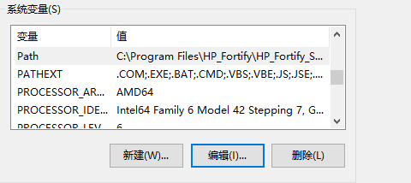
添加环境变量,保证gpg 等命令在命令行下是可用的!,添加如下路径:
C:\Program Files (x86)\GNU\GnuPG\pub
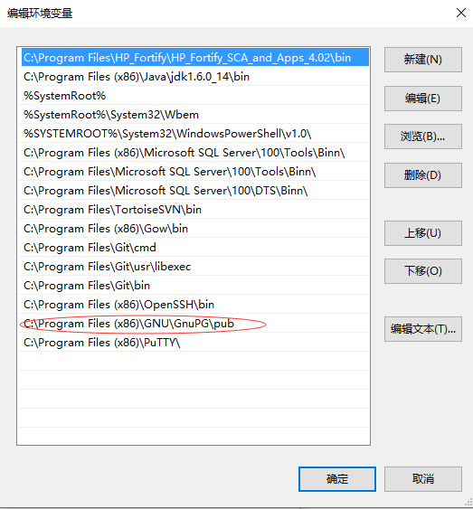

服务器端软件
yubikeylib.tgz
说明:此压缩包包含了yubico在linux版本的操作命令,。 上传到linux服务器上，解压：
tar -xzvf ./yubikeylib.tgz
cd usr/bin
设置环境变量：
export LD_LIBRARY_PATH=/root/usr/lib:/root/usr/bin:$LD_LIBRARY_PATH
export PATH=/root/usr/bin:$PATH
路径根据实际情况更改；可以配置到用户的.bash_profile中;

Yubico的配置步骤

Yubikey的初始化(初次使用,初始化可以略过),
注意：初始化会删掉key中所有的密钥；
C:\WINDOWS\system32>gpg-connect-agent --hex
> scd apdu 00 20 00 81 08 40 40 40 40 40 40 40 40
ERR 100663404 Card error <SCD>
> bye
OK closing connection
C:\WINDOWS\system32>
C:\WINDOWS\system32>gpg-connect-agent --hex
> scd apdu 00 20 00 81 08 40 40 40 40 40 40 40 40
D[0000] 69 82 .
> scd apdu 00 20 00 81 08 40 40 40 40 40 40 40 40
D[0000] 69 82 .
> scd apdu 00 20 00 81 08 40 40 40 40 40 40 40 40
D[0000] 69 82 i.
> scd apdu 00 20 00 81 08 40 40 40 40 40 40 40 40
D[0000] 69 83 .
> scd apdu 00 20 00 83 08 40 40 40 40 40 40 40 40
D[0000] 69 82 .
> scd apdu 00 20 00 83 08 40 40 40 40 40 40 40 40
D[0000] 69 82 .
> scd apdu 00 20 00 83 08 40 40 40 40 40 40 40 40
D[0000] 69 82 .
> scd apdu 00 20 00 83 08 40 40 40 40 40 40 40 40
D[0000] 69 83 .
> scd apdu 00 e6 00 00
D[0000] 90 00 ..
> scd apdu 00 44 00 00
D[0000] 90 00 ..

生成外部主密钥
C:\WINDOWS\system32>gpg --expert --gen-key
gpg (GnuPG) 2.0.30; Copyright (C) 2015 Free Software Foundation, Inc.
This is free software: you are free to change and redistribute it.
There is NO WARRANTY, to the extent permitted by law.

Please select what kind of key you want:
(1) RSA and RSA (default)
(2) DSA and Elgamal
(3) DSA (sign only)
(4) RSA (sign only)
(7) DSA (set your own capabilities)
(8) RSA (set your own capabilities)
Your selection? 8

Possible actions for a RSA key: Sign Certify Encrypt Authenticate
Current allowed actions: Sign Certify Encrypt

(S) Toggle the sign capability
(E) Toggle the encrypt capability
(A) Toggle the authenticate capability
(Q) Finished

Your selection? S

Possible actions for a RSA key: Sign Certify Encrypt Authenticate
Current allowed actions: Certify Encrypt

(S) Toggle the sign capability
(E) Toggle the encrypt capability
(A) Toggle the authenticate capability
(Q) Finished

Your selection? E

Possible actions for a RSA key: Sign Certify Encrypt Authenticate
Current allowed actions: Certify

(S) Toggle the sign capability
(E) Toggle the encrypt capability
(A) Toggle the authenticate capability
(Q) Finished

Your selection? A

Possible actions for a RSA key: Sign Certify Encrypt Authenticate
Current allowed actions: Certify Authenticate

(S) Toggle the sign capability
(E) Toggle the encrypt capability
(A) Toggle the authenticate capability
(Q) Finished

Your selection? Q
RSA keys may be between 1024 and 4096 bits long.
What keysize do you want? (2048)
Requested keysize is 2048 bits
Please specify how long the key should be valid.
0 = key does not expire
<n> = key expires in n days
<n>w = key expires in n weeks
<n>m = key expires in n months
<n>y = key expires in n years
Key is valid for? (0) 0
Key does not expire at all
Is this correct? (y/N) y

GnuPG needs to construct a user ID to identify your key.

Real name: tasskms
Email address: mengzhaoming@tass.com.cn
Comment: tass_kms_server
You selected this USER-ID:
"tasskms (tass_kms_server) <mengzhaoming@tass.com.cn>"

Change (N)ame, (C)omment, (E)mail or (O)kay/(Q)uit? O
You need a Passphrase to protect your secret key.

We need to generate a lot of random bytes. It is a good idea to perform
some other action (type on the keyboard, move the mouse, utilize the
disks) during the prime generation; this gives the random number
generator a better chance to gain enough entropy.
gpg: key 58F95AFC marked as ultimately trusted
public and secret key created and signed.

gpg: checking the trustdb
gpg: 3 marginal(s) needed, 1 complete(s) needed, PGP trust model
gpg: depth: 0 valid: 6 signed: 0 trust: 0-, 0q, 0n, 0m, 0f, 6u
pub 2048R/58F95AFC 2016-11-24
Key fingerprint = 4273 79FD 60A3 B28D 1F62 638F F3C2 0320 58F9 5AFC
uid [ultimate] tasskms (tass_kms_server) <mengzhaoming@tass.com.cn>

Note that this key cannot be used for encryption. You may want to use
the command "--edit-key" to generate a subkey for this purpose.

生成签名子密钥
C:\WINDOWS\system32>gpg -K
C:/Users/Administrator/AppData/Roaming/gnupg/secring.gpg
--------------------------------------------------------
sec 2048R/58F95AFC 2016-11-24
uid tasskms (tass_kms_server) <mengzhaoming@tass.com.cn>

C:\WINDOWS\system32>gpg --edit-key 58F95AFC
gpg (GnuPG) 2.0.30; Copyright (C) 2015 Free Software Foundation, Inc.
This is free software: you are free to change and redistribute it.
There is NO WARRANTY, to the extent permitted by law.

Secret key is available.

pub 2048R/58F95AFC created: 2016-11-24 expires: never usage: CA
trust: ultimate validity: ultimate
[ultimate] (1). tasskms (tass_kms_server) <mengzhaoming@tass.com.cn>

gpg> addkey
Key is protected.

You need a passphrase to unlock the secret key for
user: "tasskms (tass_kms_server) <mengzhaoming@tass.com.cn>"
2048-bit RSA key, ID 58F95AFC, created 2016-11-24

Please select what kind of key you want:
(3) DSA (sign only)
(4) RSA (sign only)
(5) Elgamal (encrypt only)
(6) RSA (encrypt only)
Your selection? 4
RSA keys may be between 1024 and 4096 bits long.
What keysize do you want? (2048)
Requested keysize is 2048 bits
Please specify how long the key should be valid.
0 = key does not expire
<n> = key expires in n days
<n>w = key expires in n weeks
<n>m = key expires in n months
<n>y = key expires in n years
Key is valid for? (0) 0
Key does not expire at all
Is this correct? (y/N) y
Really create? (y/N) y
We need to generate a lot of random bytes. It is a good idea to perform
some other action (type on the keyboard, move the mouse, utilize the
disks) during the prime generation; this gives the random number
generator a better chance to gain enough entropy.

pub 2048R/58F95AFC created: 2016-11-24 expires: never usage: CA
trust: ultimate validity: ultimate
sub 2048R/1C8671E8 created: 2016-11-24 expires: never usage: S
[ultimate] (1). tasskms (tass_kms_server) <mengzhaoming@tass.com.cn>

gpg> 6
No user ID with index 6

gpg> addkey
Key is protected.

You need a passphrase to unlock the secret key for
user: "tasskms (tass_kms_server) <mengzhaoming@tass.com.cn>"
2048-bit RSA key, ID 58F95AFC, created 2016-11-24

Please select what kind of key you want:
(3) DSA (sign only)
(4) RSA (sign only)
(5) Elgamal (encrypt only)
(6) RSA (encrypt only)
Your selection? 6
RSA keys may be between 1024 and 4096 bits long.
What keysize do you want? (2048)
Requested keysize is 2048 bits
Please specify how long the key should be valid.
0 = key does not expire
<n> = key expires in n days
<n>w = key expires in n weeks
<n>m = key expires in n months
<n>y = key expires in n years
Key is valid for? (0) 0
Key does not expire at all
Is this correct? (y/N) y
Really create? (y/N) y
We need to generate a lot of random bytes. It is a good idea to perform
some other action (type on the keyboard, move the mouse, utilize the
disks) during the prime generation; this gives the random number
generator a better chance to gain enough entropy.

pub 2048R/58F95AFC created: 2016-11-24 expires: never usage: CA
trust: ultimate validity: ultimate
sub 2048R/1C8671E8 created: 2016-11-24 expires: never usage: S
sub 2048R/2F48613D created: 2016-11-24 expires: never usage: E
[ultimate] (1). tasskms (tass_kms_server) <mengzhaoming@tass.com.cn>

gpg> save

备份密钥
C:\WINDOWS\system32>gpg --export-secret-key 58F95AFC>c:\keys\58F95AFC.gpg

把签名子密钥导入key
C:\WINDOWS\system32>gpg -K
C:/Users/Administrator/AppData/Roaming/gnupg/secring.gpg
--------------------------------------------------------
sec> 2048R/58F95AFC 2016-11-24
Card serial no. = 0006 04644696
uid tasskms (tass_kms_server) <mengzhaoming@tass.com.cn>
ssb> 2048R/1C8671E8 2016-11-24
ssb 2048R/2F48613D 2016-11-24

C:\WINDOWS\system32>gpg --delete-secret-key 58F95AFC
gpg (GnuPG) 2.0.30; Copyright (C) 2015 Free Software Foundation, Inc.
This is free software: you are free to change and redistribute it.
There is NO WARRANTY, to the extent permitted by law.

sec 2048R/58F95AFC 2016-11-24 tasskms (tass_kms_server) <mengzhaoming@tass.com.cn>

Delete this key from the keyring? (y/N) y
This is a secret key! - really delete? (y/N) y

C:\WINDOWS\system32>gpg --import <c:\keys\58F95AFC.gpg
gpg: key 58F95AFC: secret key imported
gpg: key 58F95AFC: "tasskms (tass_kms_server) <mengzhaoming@tass.com.cn>" not changed
gpg: Total number processed: 1
gpg: unchanged: 1
gpg: secret keys read: 1
gpg: secret keys imported: 1
C:\WINDOWS\system32>gpg --edit-key 58F95AFC
gpg (GnuPG) 2.0.30; Copyright (C) 2015 Free Software Foundation, Inc.
This is free software: you are free to change and redistribute it.
There is NO WARRANTY, to the extent permitted by law.

Secret key is available.

pub 2048R/58F95AFC created: 2016-11-24 expires: never usage: CA
trust: ultimate validity: ultimate
sub 2048R/1C8671E8 created: 2016-11-24 expires: never usage: S
sub 2048R/2F48613D created: 2016-11-24 expires: never usage: E
[ultimate] (1). tasskms (tass_kms_server) <mengzhaoming@tass.com.cn>

gpg> toggle

sec 2048R/58F95AFC created: 2016-11-24 expires: never
ssb 2048R/1C8671E8 created: 2016-11-24 expires: never
ssb 2048R/2F48613D created: 2016-11-24 expires: never
(1) tasskms (tass_kms_server) <mengzhaoming@tass.com.cn>

gpg> key 0

sec 2048R/58F95AFC created: 2016-11-24 expires: never
ssb 2048R/1C8671E8 created: 2016-11-24 expires: never
ssb 2048R/2F48613D created: 2016-11-24 expires: never
(1) tasskms (tass_kms_server) <mengzhaoming@tass.com.cn>

gpg> keytocard
Really move the primary key? (y/N) y
Signature key ....: 7E03 37F1 9561 7F4F 1AE5 4F31 589A 82AA 59BB 2AAC
Encryption key....: 02F9 8B1A 32D5 E3CC A8DB 36C3 19AA 4640 27BB 1ED9
Authentication key: 7E05 566B 9C50 94B6 3974 8455 0308 E13A C47A D1F0

Please select where to store the key:
(1) Signature key
(3) Authentication key
Your selection? 1

gpg: WARNING: such a key has already been stored on the card!

Replace existing key? (y/N) y

You need a passphrase to unlock the secret key for
user: "tasskms (tass_kms_server) <mengzhaoming@tass.com.cn>"
2048-bit RSA key, ID 58F95AFC, created 2016-11-24

sec 2048R/58F95AFC created: 2016-11-24 expires: never
card-no: 0006 04644507
ssb 2048R/1C8671E8 created: 2016-11-24 expires: never
ssb 2048R/2F48613D created: 2016-11-24 expires: never
(1) tasskms (tass_kms_server) <mengzhaoming@tass.com.cn>

gpg> key 1

sec 2048R/58F95AFC created: 2016-11-24 expires: never
card-no: 0006 04644507
ssb* 2048R/1C8671E8 created: 2016-11-24 expires: never
ssb 2048R/2F48613D created: 2016-11-24 expires: never
(1) tasskms (tass_kms_server) <mengzhaoming@tass.com.cn>

gpg> keytocard
Signature key ....: 4273 79FD 60A3 B28D 1F62 638F F3C2 0320 58F9 5AFC
Encryption key....: [none]
Authentication key: [none]

Please select where to store the key:
(1) Signature key
(3) Authentication key
Your selection? 3

You need a passphrase to unlock the secret key for
user: "tasskms (tass_kms_server) <mengzhaoming@tass.com.cn>"
2048-bit RSA key, ID 1C8671E8, created 2016-11-24

sec 2048R/58F95AFC created: 2016-11-24 expires: never
card-no: 0006 04644507
ssb* 2048R/1C8671E8 created: 2016-11-24 expires: never
card-no: 0006 04644507
ssb 2048R/2F48613D created: 2016-11-24 expires: never
gpg> save

同样的方式导入一个密钥可以导入多个key;

导出签名密钥的公钥
C:\WINDOWS\system32>gpg -K
C:/Users/Administrator/AppData/Roaming/gnupg/secring.gpg
--------------------------------------------------------
sec> 2048R/58F95AFC 2016-11-24
Card serial no. = 0006 04644696
uid tasskms (tass_kms_server) <mengzhaoming@tass.com.cn>
ssb> 2048R/1C8671E8 2016-11-24
ssb 2048R/2F48613D 2016-11-24
C:\WINDOWS\system32>gpg --armor --export 1C8671E8>c:\keys\1C8671E8.asc
PIN说明：
PIN 分为主机上主密钥的保护PIN(默认:123456)
管理员 PIN(默认12345678)
Yubukey PIN(默认123456)

服务器端的软件安装及配置

认证公钥配置
[root@kms bin]# gpg --import 1C8671E8.asc
gpg: key 58F95AFC: public key "tasskms (tass_kms_server) <mengzhaoming@tass.com.cn>" imported
gpg: Total number processed: 1
gpg: imported: 1 (RSA: 1)
[root@kms bin]# gpgkey2ssh 58F95AFC>~/.ssh/authorized_keys
[root@kms bin]# service sshd restart
Stopping sshd: [ OK ]
Starting sshd: [ OK ]

ssh_config的配置
vi /etc/ssh/sshd_config
＃禁止密码登录
PermitRootLogin without-password
PasswordAuthentication no
ChallengeResponseAuthentication no
＃允许证书登录
StrictModes no
RSAAuthentication yes
PubkeyAuthentication yes
重启ssh服务
Service sshd restart

登录测试

插入yubikey,打开pageant.exe
注意：有多把签名密钥相同的key,换key 操作,需要重启pageant.exe
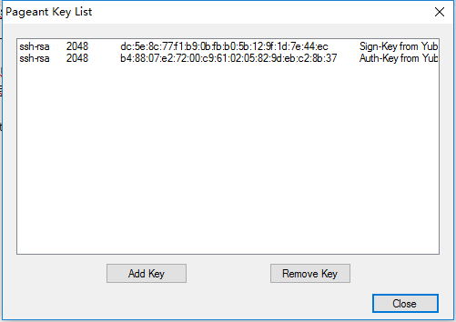

打开putty
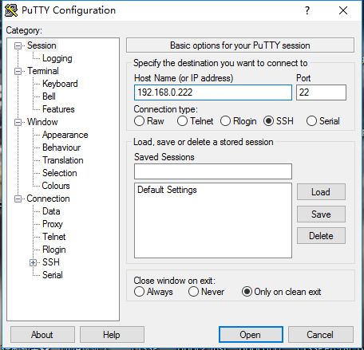
检查如下配置
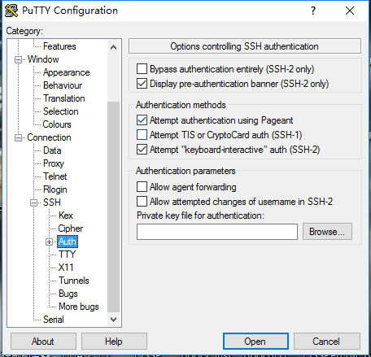
单击＂open＂,输入PIN码，默认＂123456＂
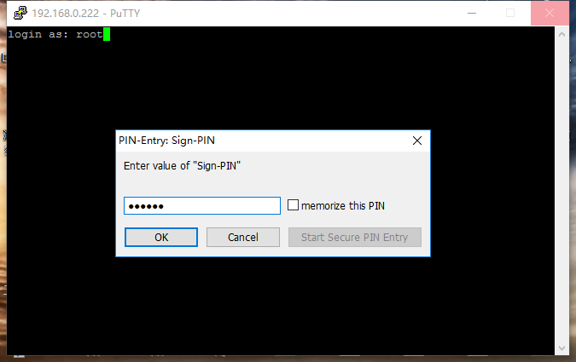
另外winscp 及FileZilla-client 工具都支持yubikey登录．

其他

修改yubikeyPIN码
C:\WINDOWS\system32>gpg --change-pin
gpg: OpenPGP card no. D2760001240102010006046445070000 detected

1 - change PIN
2 - unblock PIN
3 - change Admin PIN
4 - set the Reset Code
Q - quit

Your selection? 1
PIN changed.

1 - change PIN
2 - unblock PIN
3 - change Admin PIN
4 - set the Reset Code
Q - quit

常见问题

gpg: OpenPGP card not available: Card error
解决办法:
Gpg管理工具和pageant.exe 是冲突;
如果要用gpg 命令，请退出pageant.exe.
如果要用 pageant.exe 请在任务管理器中杀掉私钥的守护进程:
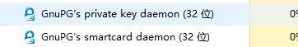

识别不到yubikey.
解决办法: 拔掉，重插!

登录报错
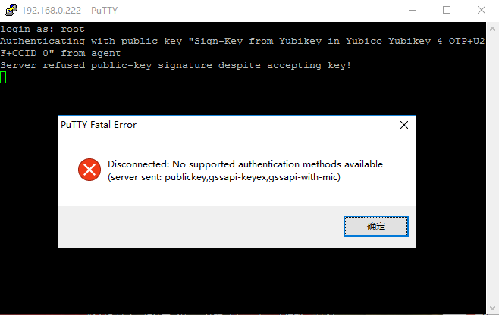
由于工具有一些缓存,来回插key ,换key可能出现此错误
- 退出pageant.exe、关闭putty、拔出key
- 插入key
- 启动pageant.exe
- 启动Putty 登录

另外输错PIN码也会出现上述错误，重新打开putty登录即可!

